Project Design Phase-II
Technology Stack (Architecture & Stack)
Date | 31/10/25
Team ID | NM2025TMID08458
Project Name | Optimization User, group and role management with access control and workflow
Maximum marks | 4 Marks

Technical Architecture
The deliverable includes the architectural diagram and detailed information as per the tables below.
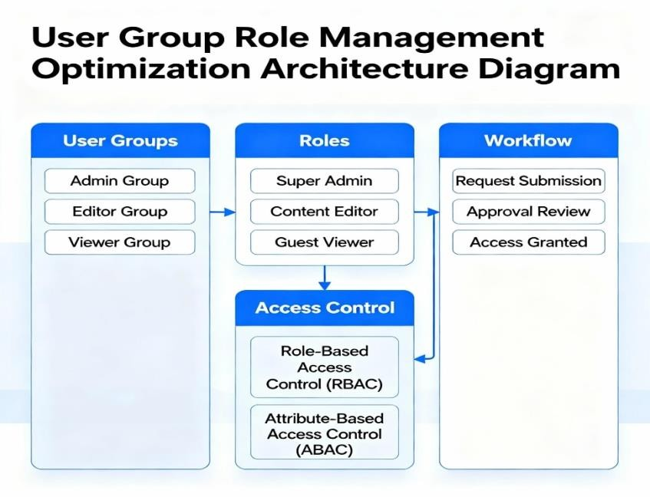

Table 1: Components & Technologies

S.NO | Component | Description | Technology
1 | User Interface | Admin and users interact via a web dashboard for managing users, | React.js / HTML/ CSS
 |  | roles, and workflows.
2 | Authentication& Authorization | Validates users and manages role-based access using secure tokens. | Node.js with JWT
3 | Role Management | Create and assign roles with specific access permissions. | Express.js , Sequelize
4 | Group Management | Organize users into logical groups for workflow routing and permission inheritance. | MySQL(Group Table)
5 | Access Control Engine | Controls access to modules based on roles and permissions. | Node.js middleware
6 | Workflow Engine | Automates approval flows and tracks process states. | Node.js Workflow Logic
7 | Notification Service | Sends alerts or approval notifications to users/managers. | Nodemailer /  Firebase Cloud  Messaging
8 | Database | Stores users, roles, groups, and workflow data. | MySQL
9 | Cloud Infrastructure | Application hosted on cloud for availability and scalability. | AWS / Azure Cloud
10 | API Layer | T APIs expose backend functions for frontend integration. | Express.js API
11 | File Storage (Optional) | Stores user-related configuration or export files. | AWS S3 / Cloud Storage

Table 2: Application Characteristics

S.NO | Characteristics | Description | Technology
1 | Open Source Framework | Built using opensource technologies to ensure flexibility. | React.js, Node.js
2 | Security  Implementation | Role-based access control (RBAC), encrypted tokens, and ACLs. | JWT, bcrypt.js
3 | Scalable  Architecture | Microservice-ready and horizontally scalable | Node.js + AWS
4 | Availability | Deployed on cloud infrastructure for 24/7 uptime. | AWS Cloud Hosting
5 | Performance | Optimized API calls, caching, and efficient queries. | Sequelize ORM, Redis (optional)
6 | Reliability | Continuous monitoring and automated backup of user data. | CloudWatch / PM2
7 | Maintainability | Modular architecture with reusable rolebased components. | MVC Design Pattern

